# Nike Shoe Brand

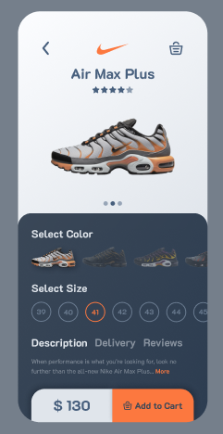We were asked to develop a screen of any app. So, I have chosen this (Nike shoe brand)

Target was to make this design.

And the Solution is :

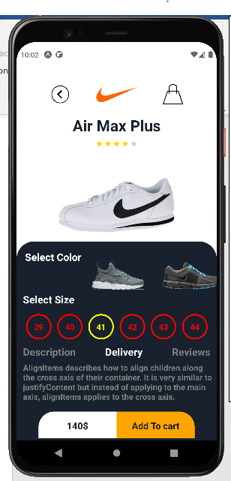

CODE :

import { StyleSheet, Text, View, Image,Touchable } from 'react-native';

import Pressable from 'react-native/Libraries/Components/Pressable/Pressable';

export default function App() {

  return (

    <>

    {/* First Layer */}

    <View style={[styles.secondSheet]}>

        <View style={{flex:0.2, width:'80%', flexDirection : 'row',marginLeft:'10%',marginTop:'10%',paddingTop:'5%',alignItems:'center',justifyContent:'space-around'}}>

            <Image

            source = {require('./assets/go-back.png')}

            style={{width:40, height:40}}

            />

            <Image

            source = {require('./assets/nike.png')}

            style={{width:90, height:90}}

            />

            <Image

            source = {require('./assets/Shopng-bag.png')}

            style={{width:40, height:40}}

            />

        </View>

        <View style={{flex:0.2, flexDirection:'row',  justifyContent:'center'}}>

          <Text style={[styles.fontComon,{ fontSize:30, textAlign:'left', color:'#18212d'}]}>Air Max Plus</Text>

        </View>

        <View style={[{flex:0.1, alignItems:'center', marginTop:-30}]}>

            <Image

              source = {require('./assets/4_start.png')}

              style={{width:100, height:10}}

              />

        </View>

        <View style={{flex:0.3, flexDirection:'row', marginTop:-50}}>

            <Image

            source = {require('./assets/shoe_pic.png')}

            style={[styles.ImgStyle]}

            />

        </View>

    </View>

{/* Second layer */}

    <View style= {[styles.secondSheet,{backgroundColor:'#18212d' }]}>

      <View style={{flex:0.2, flexDirection : 'row', marginBottom:'10%', padding:'3%'}}>

        <Text style={[styles.fontComon,{ fontSize:20, textAlign:'left'}]}>Select Color</Text>

              <Image

                source = {require('./assets/selectColor1.png')}

                style={{height:'300%',width:'40%'}}

              />

              <Image

                source = {require('./assets/selectColor3.png')}

                style={{height:100,width:'40%'}}

              />

              <Image

                source = {require('./assets/selectColor3.png')} //hidden image

                style={{height:100,width:'40%', marginTop:100}}

              />

      </View>

      <Text style={[styles.fontComon, { fontSize:20, textAlign:'left', padding:'2%'}]}>Select Size</Text>

      <View style={{flex:0.2, flexDirection : 'row',padding:'2%', justifyContent:'space-around'}}>

        <View style={[styles.circleForSizes,{borderColor:'red'}]}><Text style={[styles.fontComon,{fontSize:16, color:'red'}]} >39</Text></View>

        <View style={[styles.circleForSizes,{borderColor:'red'}]}><Text style={[styles.fontComon,{fontSize:16, color:'red'}]} >40</Text></View>

        <View style={[styles.circleForSizes,{borderColor:'yellow'}]}><Text style={[styles.fontComon,{fontSize:16, color:'yellow'}]} >41</Text></View>

        <View style={[styles.circleForSizes,{borderColor:'red'}]}><Text style={[styles.fontComon,{fontSize:16, color:'red'}]} >42</Text></View>

        <View style={[styles.circleForSizes,{borderColor:'red'}]}><Text style={[styles.fontComon,{fontSize:16, color:'red'}]} >43</Text></View>

        <View style={[styles.circleForSizes,{borderColor:'red'}]}><Text style={[styles.fontComon,{fontSize:16, color:'red'}]} >44</Text></View>

      </View>

      <View style={[{flex:0.2, marginTop:'5%', padding:'2%',flexDirection : 'row',justifyContent:'space-between'}]}>

          <Text style={[styles.fontComon,{color:'gray'}]} >Description</Text>

          <Text style={styles.fontComon}>Delivery</Text>

          <Text style={[styles.fontComon,{color:'gray'}]}>Reviews</Text>

      </View>

      <Text style={[styles.fontComon,{fontSize:16, color:'gray', marginLeft:'2%'}]}>AlignItems describes how to align children along the cross axis of their container. It is very similar to justifyContent but instead of applying to the main axis,

         alignItems applies to the cross axis.</Text>

      <View style={{flex:0.2, flexDirection : 'row',justifyContent:'space-around', marginTop:'5%',marginLeft:'10%',width:'80%', height:200 }}>

          <Pressable style={{backgroundColor:'white',height:'200%',padding:'5%', width:'50%',borderTopLeftRadius:30}}>

            <Text style={[styles.fontComon,{color:'#18212d', textAlign:'center', fontSize:18 }]}>140$</Text>

          </Pressable>

          <Pressable style={{backgroundColor:'orange',padding:'5%',height:'200%', width:'50%',  borderTopRightRadius:30}}>

            <Text style={[styles.fontComon,{color:'#18212d', textAlign:'center', fontSize:18 }]}>Add To cart</Text>

          </Pressable>

      </View>

    </View>

    </>

  );

}

const styles = StyleSheet.create({

  container: {

    flex: 1.2,

    backgroundColor: '#fff',

    alignItems: 'center',

    justifyContent: 'center',

  },

  secondSheet : {

    flex: 1,

    // backgroundColor:'red',

    borderTopRightRadius : 35,

    borderTopLeftRadius : 35,

    padding:5,

    flexWrap: "wrap",

    justifyContent: 'flex-start',

    alignItems:'stretch',

    alignContent:'stretch'

  },

  ImgStyle : {

    marginTop:'20%',

    width : '100%',

    height : '100%'

  },

  fontComon : {

    fontSize:20,

    fontWeight:'bold',

    color:'white',

    textAlign:'left'

  },

  circleForSizes : {

    height : 50 ,

    width :50,

    borderWidth: 3,

    borderColor: "white",

    // color:'yellow',

    borderRadius: 50,

    backgroundColor:'transparent',

    justifyContent: 'center',

    alignItems: 'center'

  }

});